Real Life Effects of Supply and Demand- Fabric Softener

An article written by Sharon Terlep of the Wall Street Journal on December 16th, 2016, illustrates the struggle of the fabric softener market in the United States. “Sales of the product—an often sweetly scented liquid designed to make clothes feel better after a wash—have been declining for more than a decade, hurt by improvements in modern washing machines and laundry detergents, as well as heartier fabrics able to withstand more washings without additives (Terlep).” As design and manufacturing techniques improve within the clothing market, fabric softener begins to become more and more obsolete. From the article, “Even if you are affluent or have above-average income, it’s an area where people are looking to save money (Terlep).” Families realize that it is a product that can be scratched to spare funds for more essential items. Another study from the article suggests that millennials are accelerating the fall in sales of fabric softeners. As we dive deeper into the 21st century, millennials become a bigger and bigger client base. Terlep writes “Shailesh Jejurikar, P&G’s head of global fabric care, told analysts recently that most millennials “don’t know what the product is for.” It is inevitable over the next few decades that the fabric softner industry will die down into a multi-million-dollar industry instead of multi-billion-dollar industry.

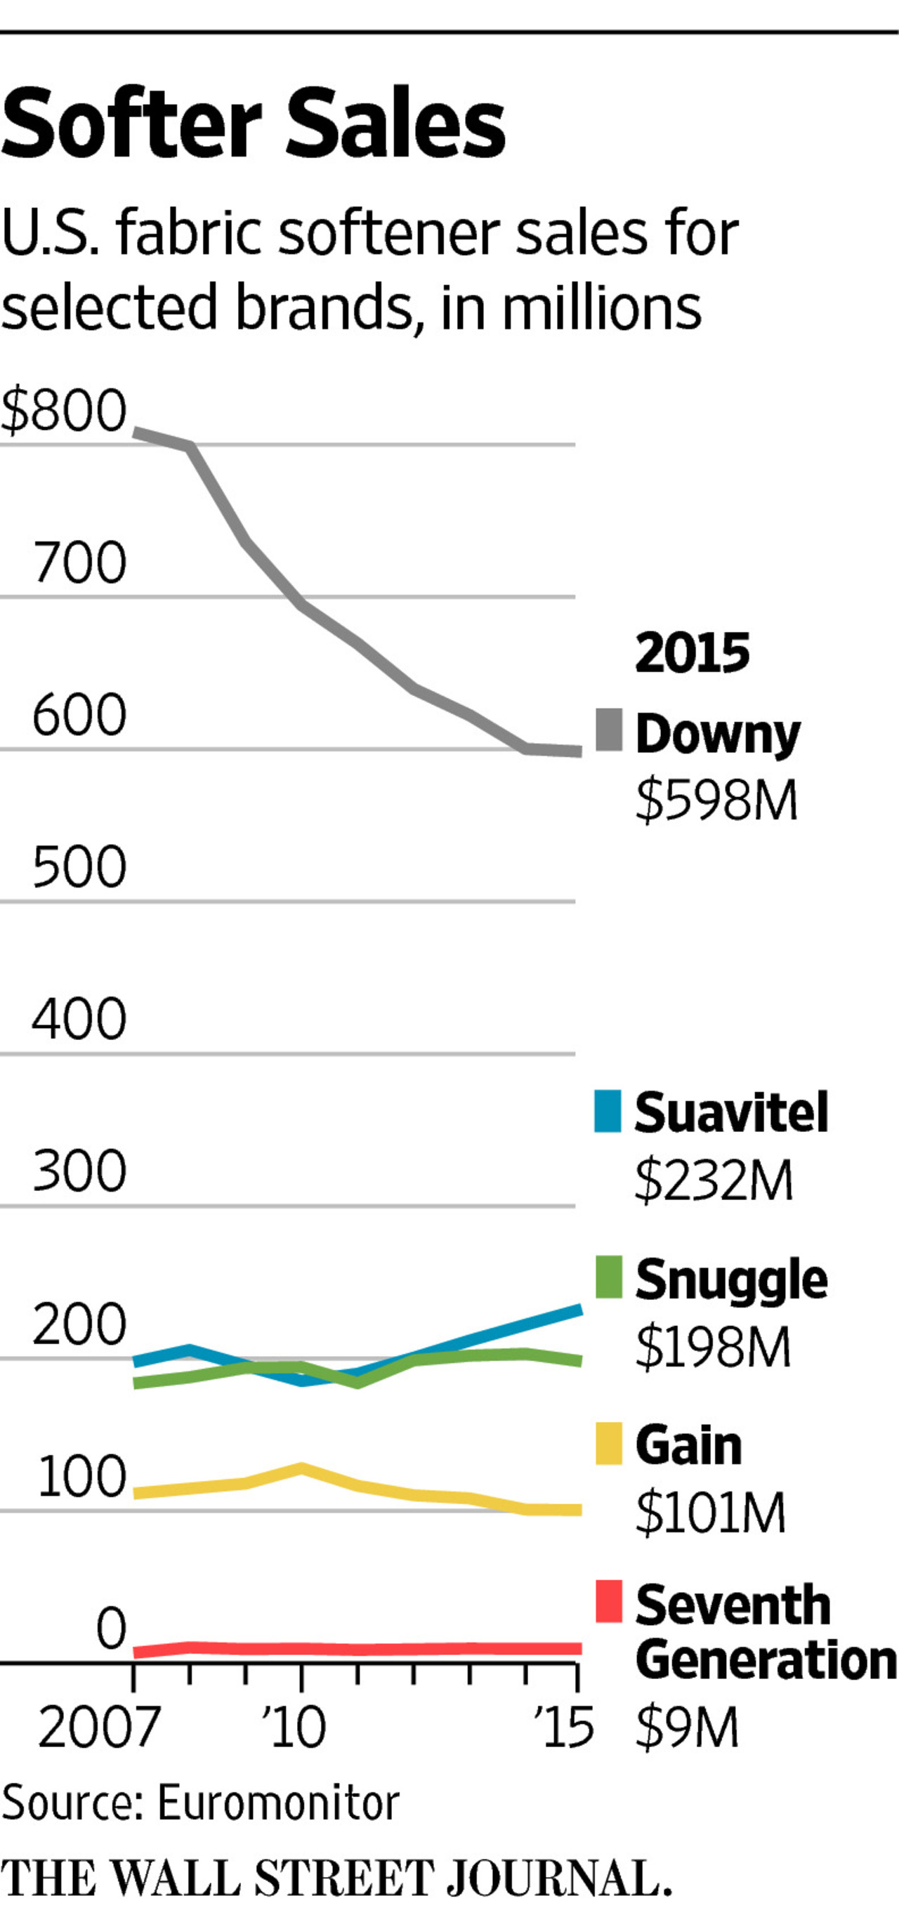

These factors of the fabric softner industry and market will affect the demand of the product immensely. The improvement of modern washing machines and fabrics that can withstand the absence of fabric softener allow the customers to no longer need the product. Millennials are beginning to become a huge part of the client base for all products. They are starting to create laundry habits and starting families. They no longer feel the need to spend money monthly on a product that is not a necessity. These factors drive down the demand for this product greatly. As each year passes by, the demand curve shifts further and further to the left. This causes the equilibrium to change, making the price lower and forcing companies to supply less. In the long term, companies will begin to drop out of the market as the client base becomes too small for companies still providing the product.

The graph to the right illustrates the fall in sales of the largest fabric softener companies over the past decade. All the factors stated above contribute to this pattern. Terlep states that the affect millennials have on the market is the biggest contributor to the fall in sales. From that, it is concluded that this industry will continue to fall as the millennials become a bigger and bigger client base.

Works Cited

Terlep, Sharon. "Millennials Are Fine Without Fabric Softener; P&G Looks to Fix That." *The Wall Street Journal*. Dow Jones & Company, 16 Dec. 2016. Web. 13 Jan. 2017.

Real Life Effects of Supply and Demand- Cuba Tourism

Azam Ahmed’s article from The New York Times posted on December 8th, 2016, illustrates the economic and social problem arising from the surge of tourism in Cuba. For decades, Cuba was a closed off society, both in traffic and trade. In the past few years, borders have opened between Cuba and the U.S., allowing tourists to enter the country. “But this year has been different, in an even more fundamental way, she said. She has not bought a single onion this year, nor a green pepper, both staples of the Cuban diet. Garlic, she said, is a rarity, while avocado, a treat she enjoyed once in a while, is all but absent from her table (Ahmed).” The surge in travel to Cuba by American tourists have left the indigenous people of the country starving. The usual 11 million people living in Cuba reached a comfortable equilibrium between salary and expenses. But, with an average of 3 million tourists in Cuba on a given day, basic staples of the Cuban diet have disappeared. “Tourists are quite literally eating Cuba’s lunch. Thanks in part to the United States embargo, but also to poor planning by the island’s government, goods that Cubans have long relied on are going to well-heeled tourists and the hundreds of private restaurants that cater to them, leading to soaring prices and empty shelves (Ahmed).” Tourists have the disposable income to purchase foods at large quantities, including foods that are usually scarce to the country’s citizens. By having ‘tourist’ catered restaurant pop up around the country, that gives those companies huge purchasing power to get the foods needed to satisfy the high-standard tourist. This leaves the scraps or nothing at all to low income families in Cuba.

This surge in population within the country of Cuba, including both citizens and tourists, have created a demand that cannot be met with the current production of supply. Farms are unable to keep up with the demand of the country. This increase in demand of common food have created a gap within the market. Food prices increase. This increase makes families willing to spend the previous amount of money for food will no longer buy it. This changes the market drastically. If a solution is not introduced to the problem, it will become a national problem resulting in extreme starvation.

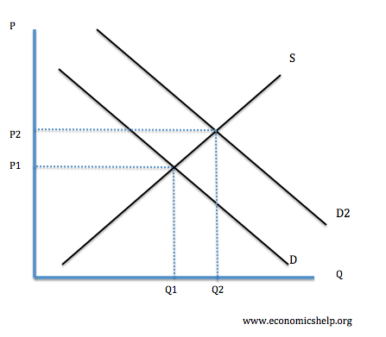

The graph to the right illustrated the change in equilibrium position for common foods in Cuba. By having an increase in demand, the quantity demanded and price of the good will increase. This leads to families not being able to afford the items they bought before. Solutions will need to be presented to the market to stabilize it to benefit the Cuban citizens.

Works Cited

Ahmed, Azam. "Cuba’s Surge in Tourism Keeps Food Off Residents’ Plates." *The New York Times*. The New York Times, 8 Dec. 2016. Web. 13 Jan. 2017.